Chapter 6, Solution 15.

Arranging the capacitors in parallel results in circuit shown in Fig. (1) (It should be noted that the resistors are in the circuits only to limit the current surge as the capacitors charge. Once the capacitors are charged the current through the resistors are obviously equal to zero.):

v₁ = v₂ = 100
(1)
C₂
+
v₂
−
100V

+
−
+
v₁
−
C₁
+ −
v₁
(2)
C₂
+
v₂
−
100V

+
−
C₁
R
R

w₂₀ = 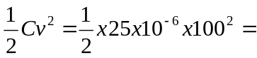 125 mJ
w₃₀ = 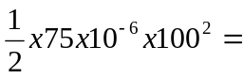 375 mJ

- Arranging the capacitors in series results in the circuit shown in Fig. (2):

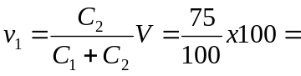75 V, v₂ = 25 V

w₂₅ = 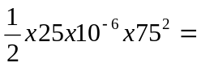70.31 mJ

w₇₅ = 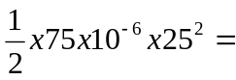 23.44 mJ.

(a) 125 mJ, 375 mJ (b) 70.31 mJ, 23.44 mJ

